**EAT AND ROLL - AN ONLINE FOOD ORDERING SYSTEM**

**PRATHEESH J V**

**(71762251022)**

**SOORYA HARSHA P**

**(71762251035)**

DISSERTATION SUBMITTED IN PARTIAL FULFILLMENT OF THE

REQUIREMENTS FOR THE DEGREE OF

M.C.A (Master of Computer Applications) OF ANNA UNIVERSITY



July 2023

**DEPARTMENT OF COMPUTER APPLICATIONS COIMBATORE INSTITUTE OF TECHNOLOGY**

**(Autonomous Institution affiliated to Anna University)**

**COIMBATORE – 641014**

**COIMBATORE INSTITUTE OF TECHNOLOGY**

**(Autonomous Institution affiliated to Anna University)**

**COIMBATORE 641014**

(Bonafide Certificate)

Mini-Project Work

Second Semester

**EAT AND ROLL - AN ONLINE FOOD ORDERING SYSTEM**

Bonfide record of Work done by

**PRATHEESH J V**

**(71762251022)**

**SOORYA HARSHA P**

**(71762251035)**

Submitted in partial fulfillment of the requirements for the degree of

M.C.A. (Master of Computer Applications) of Anna University

July 2023

_____________ ________________

Faculty Guide Head of the Department

Submitted for the viva-voce held on _________________

__________________ __________________

Internal Examiner External Examiner

**CONTENTS**

# CHAPTER PAGE NO

ACKNOWLEDGEMENT i

SYNOPSIS ii

PREFACE iii

# I INTRODUCTION

1.1 PROBLEM DEFINITION

1.2 SYSTEM ENVIRONMENT

# II SYSTEM ANALYSIS

2.1 SYSTEM DESCRIPTION

2.2 LITERATURE STUDY

2.3 USE CASE MODEL / BLOCK DIAGRAM (for IoT projects)

2.4 SOFTWARE REQUIREMENTS SPECIFICATION

# III SYSTEM DESIGN

3.1 ARCHITECTURAL DESIGN

3.2 STRUCTURAL DESIGN

3.3 BEHAVIOURAL DESIGN

3.4 TABLE DESIGN

3.5 USER INTERFACE DESIGN

3.6 CODE DESIGN

**IV** **SYSTEM TESTING**

4.1 TEST CASES AND TEST REPORTS

# V SYSTEM IMPLEMENTATION VI CONCLUSION

BIBLIOGRAPHY

APPENDIX

PUBLICATIONS

# ACKNOWLEDGEMENT

We take this opportunity with great pleasure, deep satisfaction and gratitude, to the contribution of many individuals for the successful completion of this mini project.

We express our hearty gratitude to **Dr.A. RAJESWARI**, Principal, Coimbatore Institute of Technology, Coimbatore.

We are extremely grateful to **Dr.R.S. SOMASUNDARAM**, Head, Department of Computer Applications, Coimbatore Institute of Technology,

We are thankful to our guide **Dr.J.B. JONA**, Assistant Professor, Department of Computer Applications, Coimbatore Institute of Technology, Coimbatore.

We also express our sincere thanks to all faculty and technical staff of the Department of Computer Applications for their motivation and encouragement.

i

# ABSTRACT

* An Online Food Ordering System is proposed here which simplifies the food ordering process. The proposed system shows an user interface and update the menu with all available options so that it eases the customer work. Customer can choose multiple foods from multiple restaurants to make an order and can choose the payment method that they prefer .

* The order confirmation is sent to the customer. The order is placed in the queue and updated in the database and returned in real time. This system assists the staff to go through the orders in real time and process it efficiently with minimal errors.

* The online food ordering system will provide a number of benefits for both customers and restaurants. For customers, the system will make it easier and more convenient to order food online. For restaurants, the system will provide a way to manage orders more efficiently and track inventory more effectively.

ii

# PREFACE

## I. INTRODUCTION

This chapter introduces the Online Food Ordering System. It elaborates the problem selection, problem statement, solution to the problem and the social impact.

## II. TECHNICAL INFORMATION

This chapter contains information about the system requirements, software requirements specification and both functional and non-functional requirements.

## III. SYSTEM DESIGN

This chapter contains details about the architecture of the Online Food Ordering System and the data flow diagram. It also contains sequence diagrams and all the tables that are used in this application.

## IV. PROTOTYPE

This chapter explains the prototype UI design of the Online Food Ordering System and the code.

## V. CONCLUSION

This chapter concludes by specifying the uses of the Online Food Ordering System if it is implemented successfully in real world.

iii

`

# I INTRODUCTION

## 1.1 PROBLEM DEFINITION

Inconvenience in the traditional food ordering process: The traditional process of ordering food through phone calls or in-person visits to restaurants can be time-consuming and inconvenient for customers. There is a need for an online platform that streamlines the ordering process, saving time and effort for customers.

Limited accessibility and availability: Many restaurants only accept orders during specific hours or have limited delivery options. This restricts customers from ordering their preferred meals at their convenience. The online food ordering system should provide a 24/7 accessible platform that allows customers to place orders and select delivery or pickup times according to their preferences.

Lack of transparency and information: Customers often face challenges in accessing comprehensive menus, detailed dish descriptions, ingredients, and pricing information. The system should provide a user-friendly interface that allows customers to browse through complete menus, view high-quality images of dishes, access nutritional information, and make informed decisions.

Inefficient order management for restaurants: Traditional methods of order management can lead to errors, miscommunication, and delays in processing orders. The online food ordering system should provide a streamlined order management interface for restaurants, facilitating accurate order processing, minimizing errors, and improving efficiency.

Limited payment options: Traditional food ordering methods often have limited payment options, such as cash on delivery. The system should integrate multiple secure online payment gateways to offer customers a variety of convenient payment methods, including credit/debit cards, digital wallets, and online banking.

### 1.2.1 HARDWARE REQUIREMENT SPECIFICATION

Technical descriptions of the computer components and capabilities are described by hardware specification. The hardware specification for the EatAnd Roll- An online food ordering system is given below.

* Processor: Intel i3
* Processor speed: 3.7 GHz
* RAM: 4 GB (Min)
* Hard Disk: 100 GB

### 1.2.2 SOFTWARE REQUIREMENTS SPECIFICATION

The software descriptions of the hackathon and its functionality are explained in the software specification. Software requirements are given below.

* Operating system : Windows OS
* Front-end : HTML, CSS,JavaScript, JQuery, Ajax,Python
* Back-end : PostgreSql
* Framework : django

# II SYSTEM ANALYSIS

**2.1 SYSTEM DESCRIPTION**

## EXISTING SYSTEM

The current system may have a limited number of restaurants available for ordering, restricting the choices for customers.There could be instances where the menu items or prices displayed on the platform do not match the actual offerings or prices at the restaurants, leading to confusion and dissatisfaction for customers.The existing system may have a complex or unintuitive user interface, making it difficult for customers to browse through menus, customize orders, or find relevant information.Customers may not receive timely updates on the status of their orders, causing frustration and uncertainty about when their food will be delivered.The system may experience glitches or errors during the payment process, leading to failed transactions or double charges, which can result in inconvenience and dissatisfaction for customers.The system may lack effective order management features, leading to delays or errors in processing orders, which can impact delivery times and overall customer experience.

## PROPOSED SYSTEM

The proposed online food ordering system provides customers with the convenience of ordering food from their favourite restaurants through a web-based platform or mobile application. The system allows users to browse through a variety of menus, select dishes, customize their orders, and make payments electronically.

Upon accessing the online food ordering system, customers are required to create an account by providing their personal information, including name, contact details, and delivery address. Registered users can log in to the system using their credentials and access various functionalities.

The system allows customers to search for nearby restaurants based on location, Users can view restaurant profiles, including their menu, prices. They can add items to their virtual shopping cart, customize their orders, and proceed to the checkout process. Customers are presented with various payment options, such as credit/debit card, digital wallets, or cash on delivery. Once the payment is completed, the order is confirmed, and the customer receives an order confirmation with details such as estimated delivery time. Overall the proposed online food ordering system simplifies the process of ordering food by providing a user-friendly platform, a wide selection of restaurants and menus, secure payment options.

### 2.2 USE CASE MODEL

The use case diagram is the simplest way of understanding the system. It summarizes the details of the system and the interactions with the system. The various components of the basic use case model are Actor, use cases, and associations. A use case means essential functionality of any working system. The following figure 2.1 depicts the use case diagram for the proposed system which provides a visual representation of the main functionalities and interactions Online Food Ordering System. It illustrates the different actors involved, such as donors and registered users, along with the system itself. The diagram showcases key use cases, including donors, registering the food details, requesting the food from donor, feedback from receiver. Each use case outlines the steps and interactions involved in completing specific tasks within the application. The use case diagram serves as a valuable tool for understanding the application's functionality, identifying user interactions, and providing a foundation for further development, testing, and documentation.

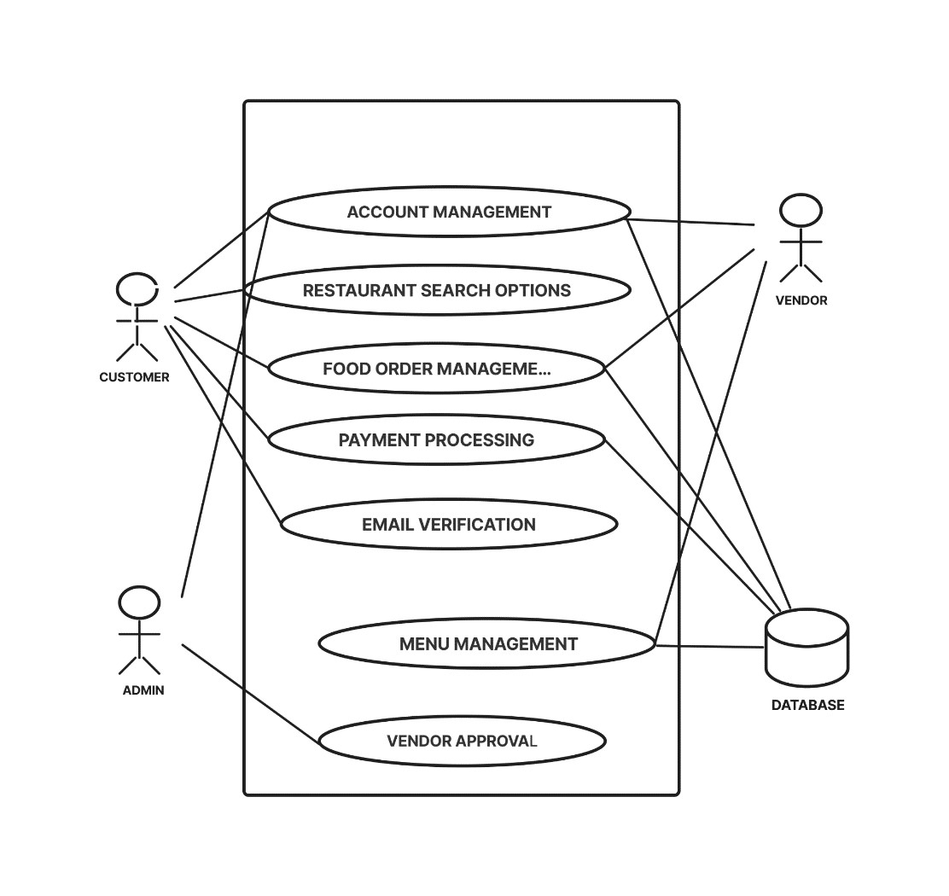

**2.4 SOFTWARE REQUIREMENTS SPECIFICATION**

## FUNCTIONAL REQUIREMENT

* **User Registration and Authentication**: Users should be able to create accounts by providing their personal information, email account, and optional contact details. The system should verify user credentials during login to ensure secure access to their accounts**.**

* **Vendor Management**: Vendors should be able to register their profiles and provide necessary information such as contact details, menu items, and pricing. The system should facilitate the onboarding process for new vendors, including verification of their credentials. Vendors should be able to create, update, and manage their menus, including adding new dishes, setting prices, and specifying availability
* **Email Verification:** The user account will be activated only after the user has verified his account through the link sent to his/her email account. The vendor account verification status will also be updated through the email account.
* **Advanced Search:** The customers will be able to search for the vendors available in a particular range of area through the filter option implemented with the help of geocoding and places API. The exact latitude and longitude details can the fetched with the help of these API’s. Similarly with the help of googles auto complete and places API’s the expected places will be auto suggested in the searchbox.
* **Edit profile:** Both the customers and vendors will be able to edit their profiles including changing names,address,profile photo and location details etc.
* **Order Placement and Summary:** Users should be able to add items from multiple vendors to their shopping cart, specify quantities, and customize orders. Users should have a clear summary of their order, including items, quantities, and total cost, before proceeding to checkout.

## NON- FUNCTIONAL REQUIREMENTS

* **Performance:** The system should provide quick responses to user actions, ensuring minimal delay in processing orders, payments, and other operations. The system should handle a large number of concurrent users and transactions without performance degradation**.**
* **Reliability:** The system should be highly available, minimizing downtime and ensuring continuous operation. The system should be able to recover gracefully from failures, ensuring that critical functions remain operational.Regular data backups should be performed to protect against data loss, and there should be a robust recovery mechanism in place.

* **Security:** Authentication and authorization: The system should have secure mechanisms for user authentication and authorization to ensure that only authorized personnel can access sensitive information or perform critical actions. Sensitive user data, such as personal information and payment details, should be encrypted and stored securely to prevent unauthorized access.
* **Scalability:** The system should be able to handle increasing workload by adding more resources to individual components.The system should support adding more vendor partners and handling a growing number of users without significant performance degradation.
* **Usability:** The system should have an intuitive and user-friendly interface that allows vendors to easily manage their menus, track orders, and perform other relevant tasks. The system should provide clear documentation and training resources to help vendors understand and effectively use the system's features.

# III SYSTEM DESIGN

## 3.1 ARCHITECTURL DESIGN

Architecture diagramming is the process of creating visual representations of software system components. In a software system, the term architecture refers to various functions, their implementations, and their interactions with each other. As software is inherently abstract, architecture diagrams visually illustrate the various data movements within the system. They also highlight how the software interacts with the environment around it.

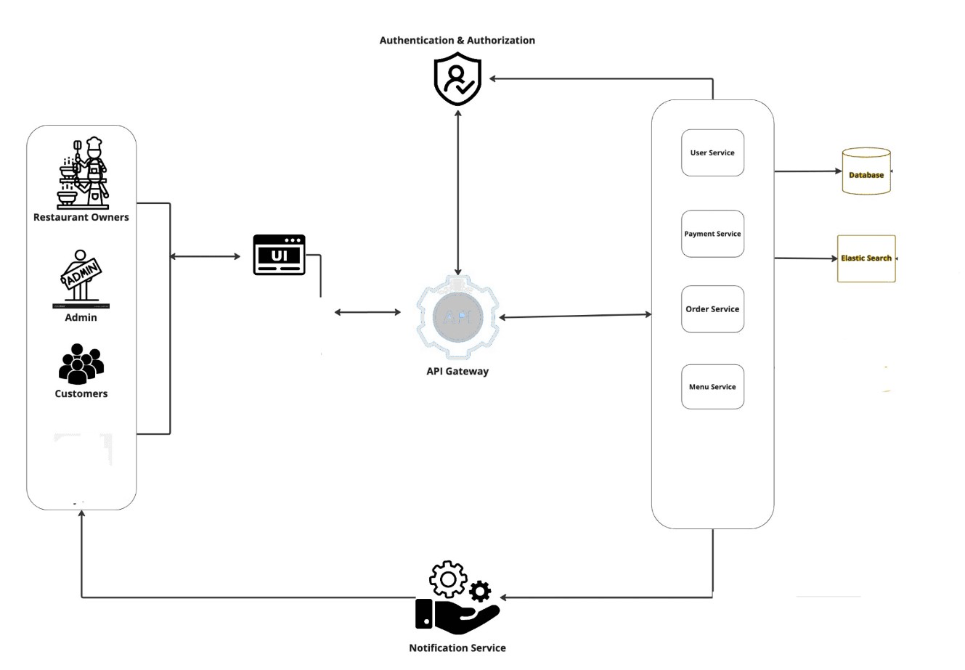

**Fig.3.1 ARCHITECTURAL DESIGN**

## 3.2 STRUCTURAL DESIGN

DFD Level 0 is also called a Context Diagram. It's a basic overview of the whole system or process being analysed or modelled. It's designed to be an at-a-glance view, showing the system as a single high-level process, with its relationship to external entities.

## Fig.3.2 DFD LEVEL 0

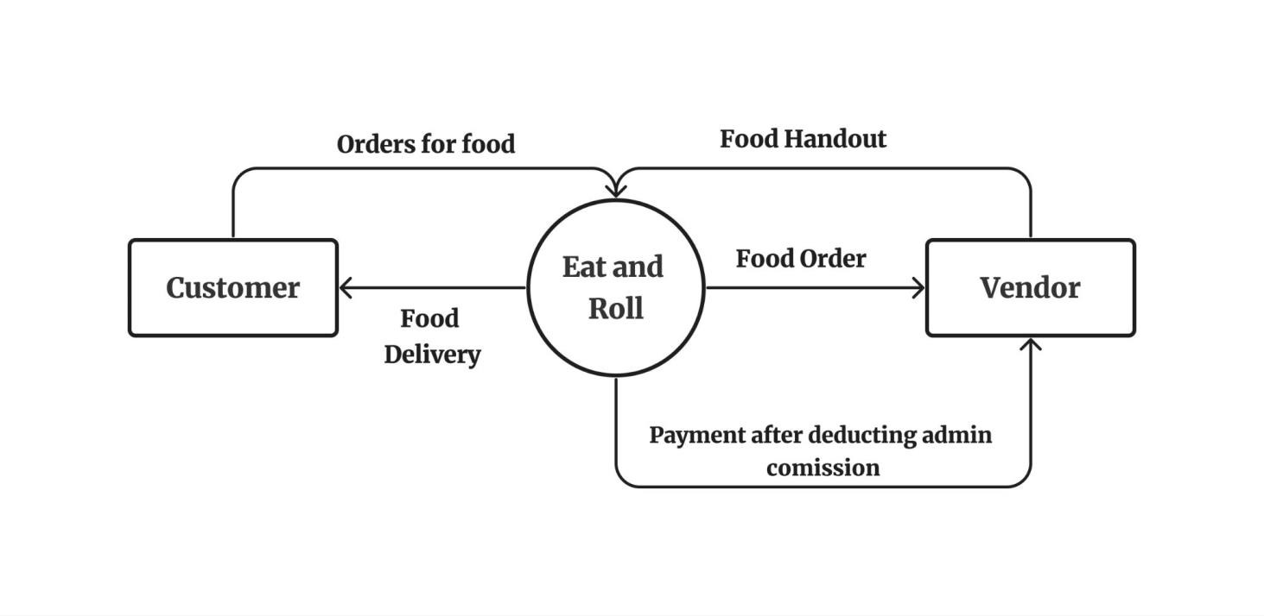

**3.3 BEHAVIOURAL DESIGN**

### Activity Diagram

A activity diagram simply depicts visual representation of the flow of activities or processes within a system or project. It is a type of behavioral diagram in UML that shows the sequence and dependencies of various activities or actions. It represents the flow of activities or actions within a system or process. It visually depicts the sequential and parallel steps involved in completing a specific task or achieving a particular goal. Activity diagrams are commonly used in software development and business process modeling to analyze, design, and document workflows.

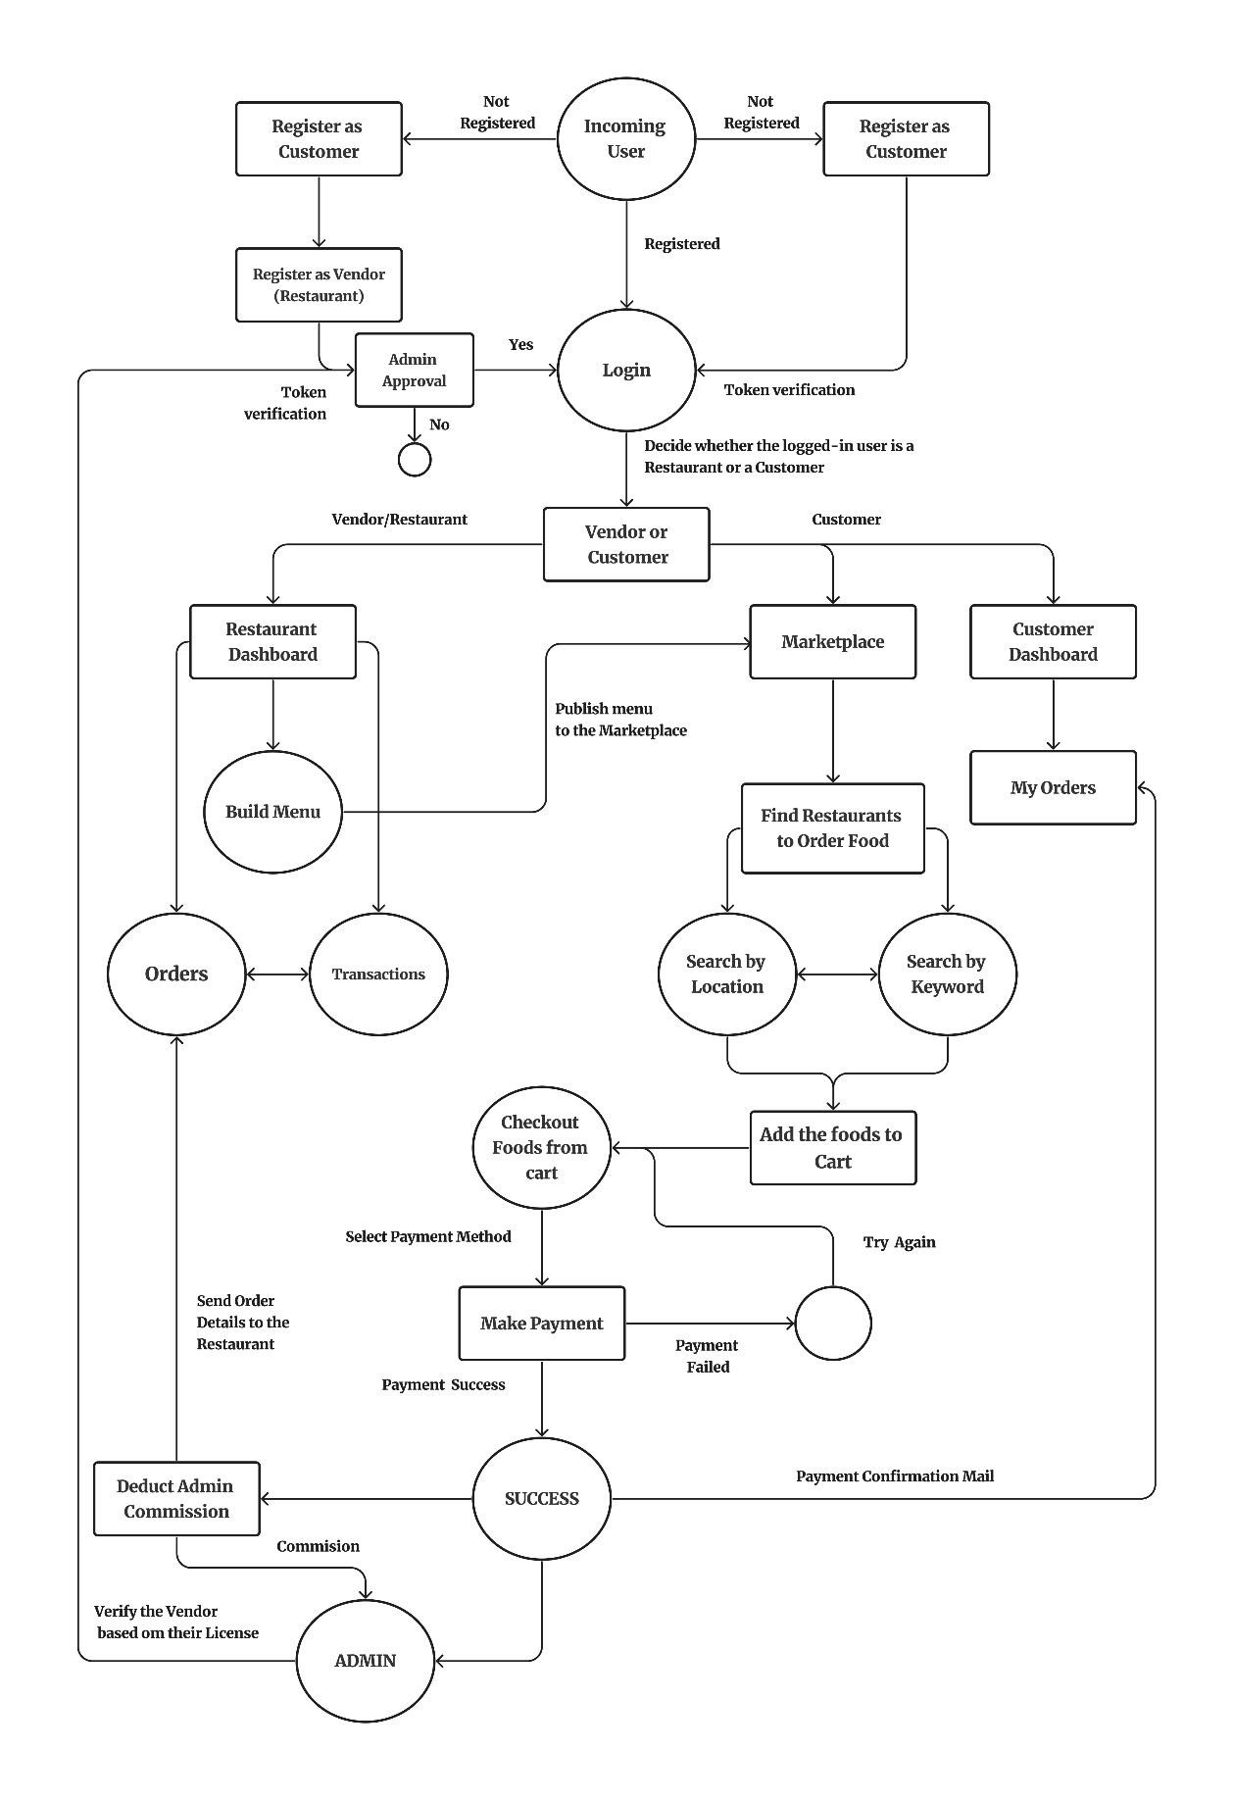

**Activity Diagram Online Food Ordering**

## 3.4 TABLE DESIGN

### CUSTOMER TABLE

The customer table is used to keep track of all registered users on a website or application. This information can be used to identify between users, vendors, admin authenticate users, and send users notifications.

**3.4.1 USER TABLE**

|  |  |  |  |
| --- | --- | --- | --- |
| **Field Name** | **Data Type** | **Description** | **Constrains** |
| User_id | Bigint | User ID | Primary key |
| First_name | Character varying (50) | First name of User | Not Null |
| Last_name | Character varying (50) | Last name of User | Not Null |
| Email | Character varying (100) | Email Id of the User | Unique = True |
| Username | Character varying (100) | Username for the account | Unique = True |
| Password | Character varying (128) | Password of the user | Not Null |
| Phone_number | Bigint | Phone number of the user | Not Null |
| Role | Smallint | 1 represents Vendor account and 2 represents Customer account | Not Null |
| Is_admin | Bool | Tells whether the user is admin or not | Default = False |
| Is_active | Bool` | Tells whether the account is activated or not | Default = False |
| Created_date | Timestamp with timezone | Date and time of the account creation | Not Null |
| Modified_date | Timestamp with timezone | Date and time of the account modified | Not Null |
| Last_login | Timestamp with timezone | Date and time of the last login | Not Null |

**3.4.2 USER PROFILE TABLE**

|  |  |  |  |
| --- | --- | --- | --- |
| **Field Name** | **Data Type** | **Description** | **Constrain** |
| User_profile_id | Bigint | User profile ID | Primary key |
| User_id | Bigint | User ID | Foreign key |
| Profile_picture | Character varying (30) | URL of the user cover photo | Only jpg,jpeg and png |
| Cover_photo | Character varying (30) | URL of the user cover photo | Only jpg,jpeg and png |
| address | Character varying (30) | Address of the User | Not Null |
| Country | Character varying (30) | Country of the user | Not Null |
| State | Character varying (30) | State of the user | Not Null |
| City | Character varying (30) | City of the user | Not Null |
| Pin_code | int | Pin_code of the user address | Not Null |
| Created_at | Timestamp with time zone | Date and time of the account creation | Not Null |
| Modified_at | Timestamp with time zone | Date and time of the account modified | Not Null |

**3.4.3 VENDOR TABLE**

|  |  |  |  |
| --- | --- | --- | --- |
| **Field Name** | **Data Type** | **Description** | **Constrain** |
| Vendor_id | Bigint | Vendor ID | Primary Key |
| User_id | Bigint | User ID | Foreign key |
| User_profile_id | Bigint | User profile ID | Foreign key |
| Vendor_name | Character varying (50) | Name of the vendor | Not Null |
| Created_at | Timestamp with time zone | Date and time of the account creation | Not Null |
| Modified_at | Timestamp with time zone | Date and time of the account modified | Not Null |

**3.4.4 CATEGORY TABLE**

|  |  |  |  |
| --- | --- | --- | --- |
| **Field Name** | **Data Type** | **Description** | **Constrain** |
| Category_id | Bigint | Category ID | Primary Key |
| Vendor_id | Bigint | Vendor ID | Foreign Key |
| Category_name | Character varying (50) | Name of the food Category | Not Null |
| Description | Text | Description of the category | Null = True |
| Created_at | Timestamp with time zone | Date and time of the account creation | Not Null |
| Updated_at | Timestamp with time zone | Date and time of the category modified | Not Null |

**3.4.5 FOOD ITEM TABLE**

|  |  |  |  |
| --- | --- | --- | --- |
| **Field Name** | **Data Type** | **Description** | **Constrain** |
| Food_title_id | Bigint | Food ID | Primary Key |
| Category_id | Bigint | Category Id | Foreign Key |
| Vendor_id | Bigint | Vendor Id | Foreign Key |
| Food_title_slug | Character varying (50) | Slug of the Vendor | Unique = True |
| Vendor_license | Character varying (50) | URL of the vendor license | Not Null |
| Food_title | Character varying (50) | Name of the food | Not Null |
| Description | Text | Description of the Food | Null = True |
| Price | Numeric (10,2) | Price of the food item | Not Null |
| Created_at | Timestamp with time zone | Date and time of the Account created | Not Null |
| Updated_at | Timestamp with time zone | Date and time of the food item details last modified | Not Null |

**3.4.5 PAYMENT TABLE**

|  |  |  |  |
| --- | --- | --- | --- |
| **Field Name** | **Data Type** | **Description** | **Constrain** |
| Payment_id | Bigint | ID of the Payment | Primary Key |
| User_id | Bigint | ID of the user | Foreign Key |
| Transaction_id | Character varying(100) | ID of the transaction | Not Null |
| Payment_method | Character varying(100) | Method of Payment  (Paypal / razorpay) | Not Null |
| Amount | Int | Amount of the ordered food | Not Null |
| Status | Character varying(100) | Success or Failure status of the payment | Not Null |
| Created_at | Timestamp with the time zone | Date and time of the payment | Not Null |

**3.4.6 ORDER TABLE**

|  |  |  |  |
| --- | --- | --- | --- |
| **Field Name** | **Data Type** | **Description** | **Constrain** |
| Order_id | Bigint | ID of the Order | Primary Key |
| Payment_id | Bigint | ID of the Payment | Foreign Key |
| User_id | Bigint | ID of the User | Foreign Key |
| Order_number | Character varying(20) | Order number | Unique = True |
| First_name | Character varying (50) | First name of User | Not Null |
| Last_name | Character varying (50) | Last name of User | Not Null |
| Email | Character varying (100) | Email Id of the User | Unique = True |
| Address | Character varying (30) | Address of the Customer | Not Null |
| Country | Character varying (30) | Country of the Customer | Not Null |
| State | Character varying (30) | State of the Customer | Not Null |
| Pin_code | Int | Pin_code of the Customer address | Not Null |
| Tax_data | Jasonb | GST and CSGT of the ordered food | Not Null |
| Total_tax | Int | Sum of both GST and CGST | Not Null |
| Payment_method | Character varying(20) | Method of payment (Paypal / Razorpay) | Not Null |
| Is_ordered | Bool | Wheather the food is Ordered or not | Not Null |
| Created_at | Timestamp with time zone | Date and time of the Account created | Not Null |
| Updated_at | Timestamp with time zone | Date and time of the food item details last modified | Not Null |

**3.5 USER INTERFACE DESIGN :**

**SCREEN SHOTS :**

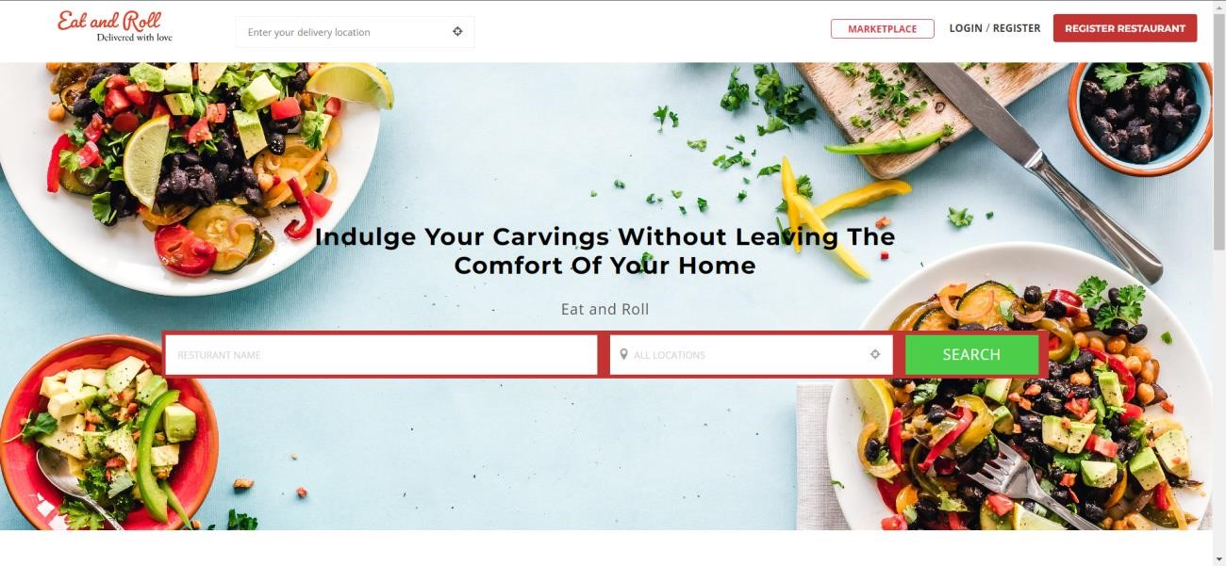

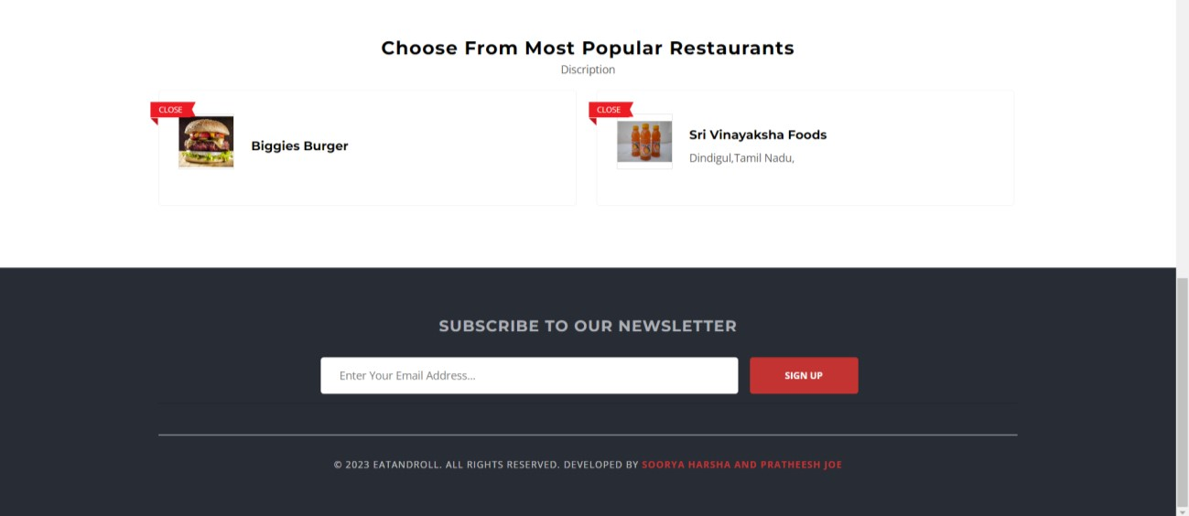

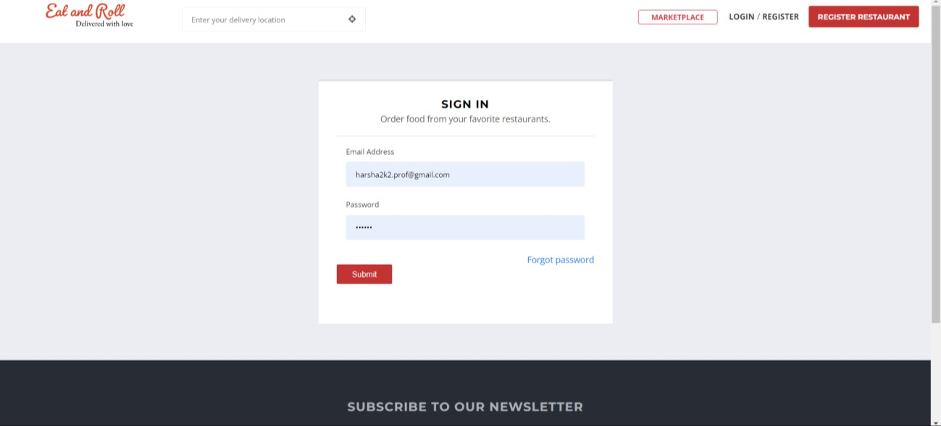

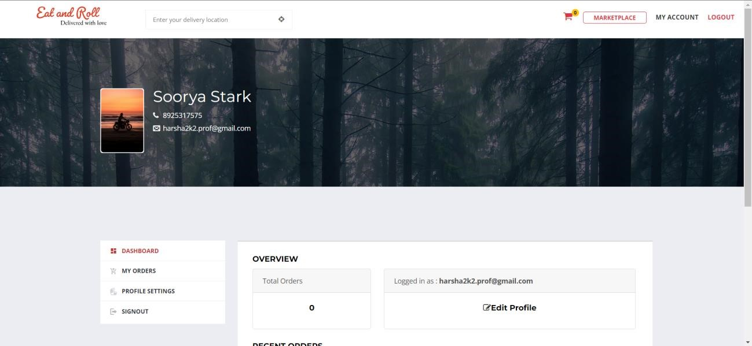

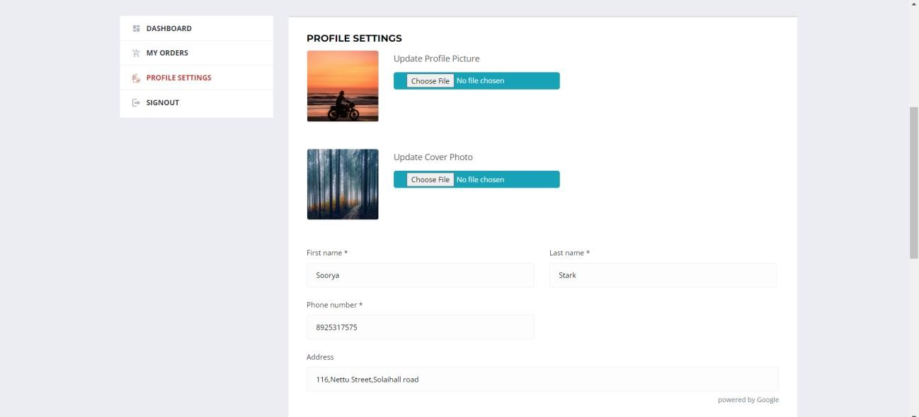

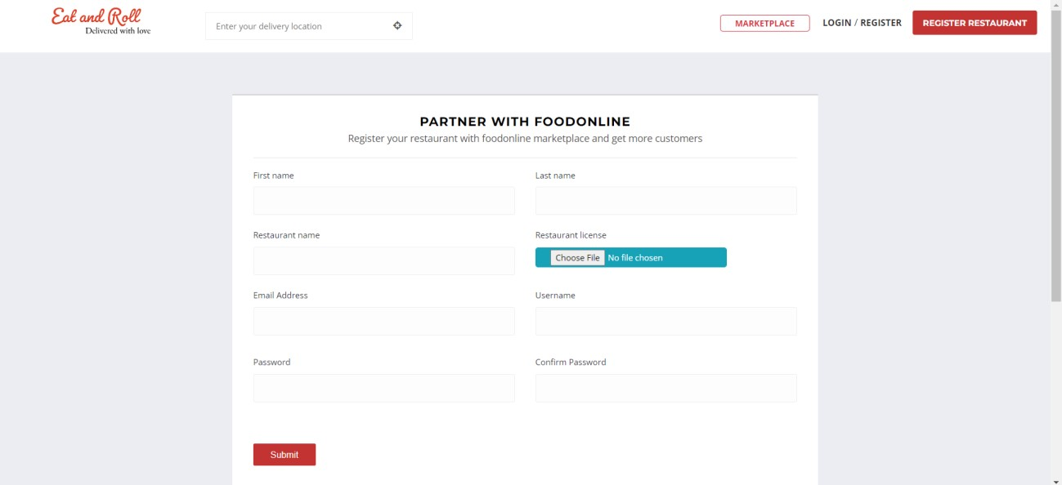

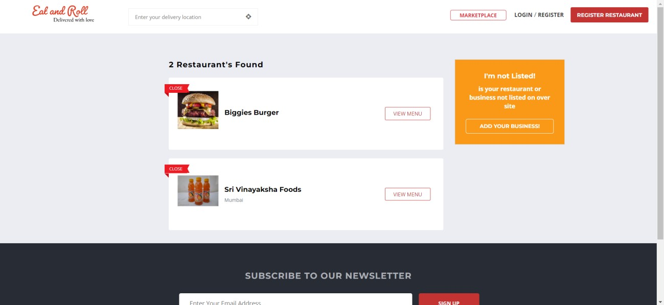

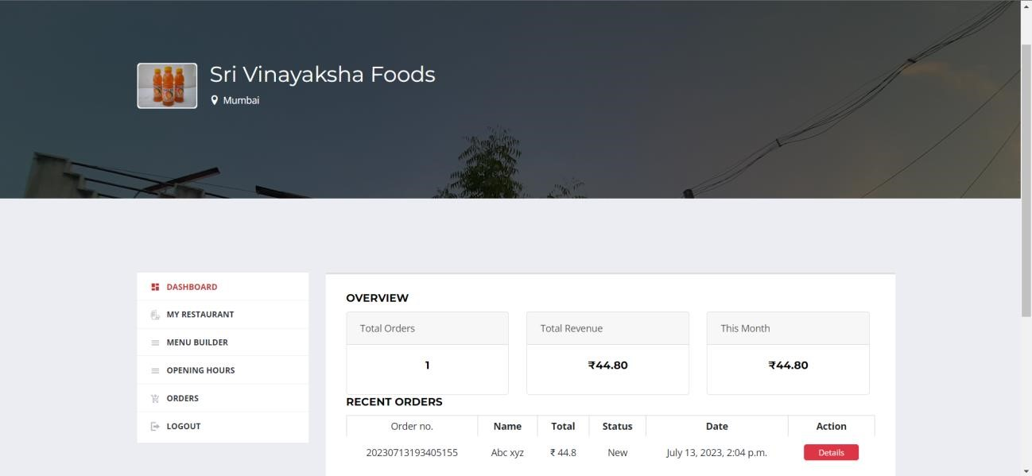

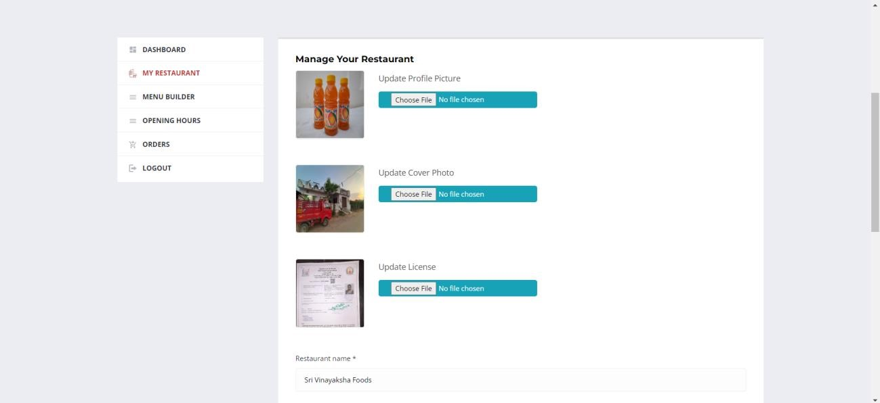

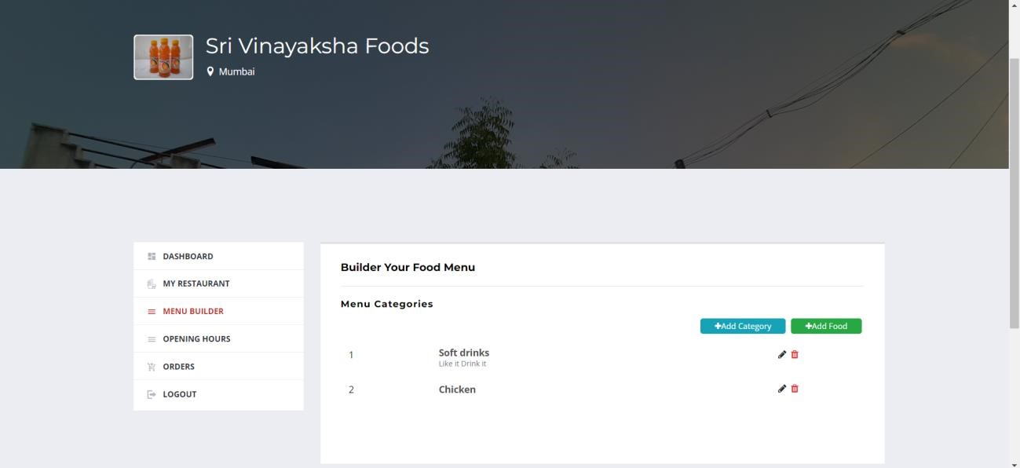

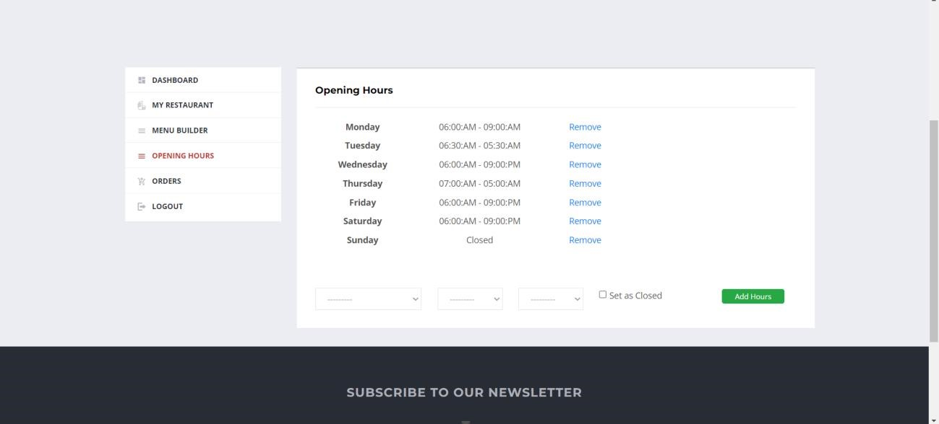

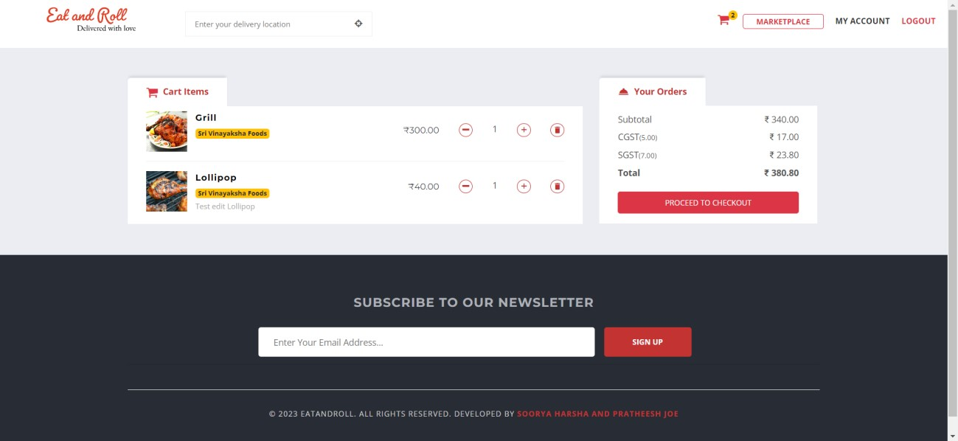

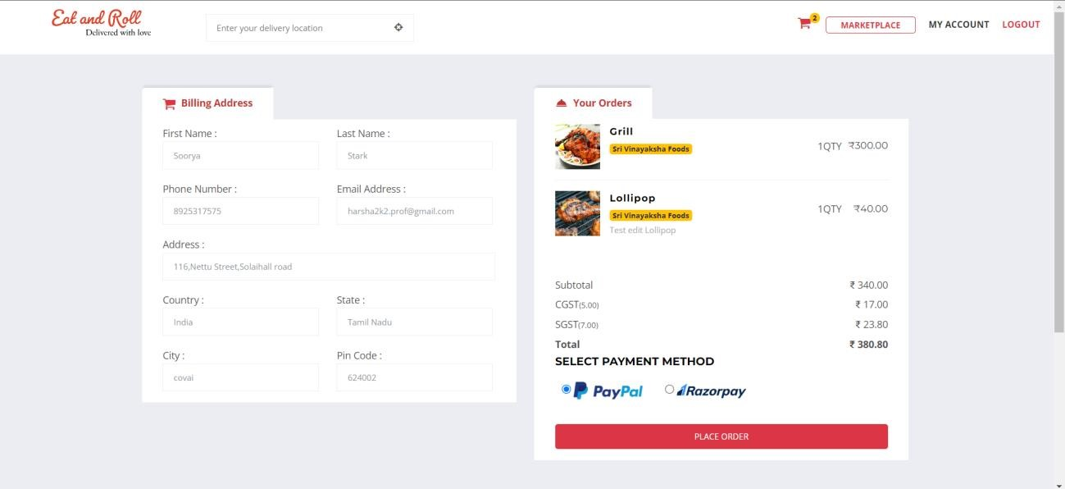

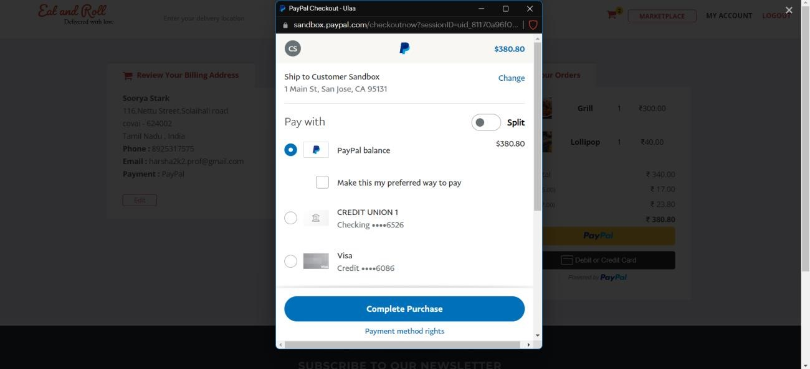

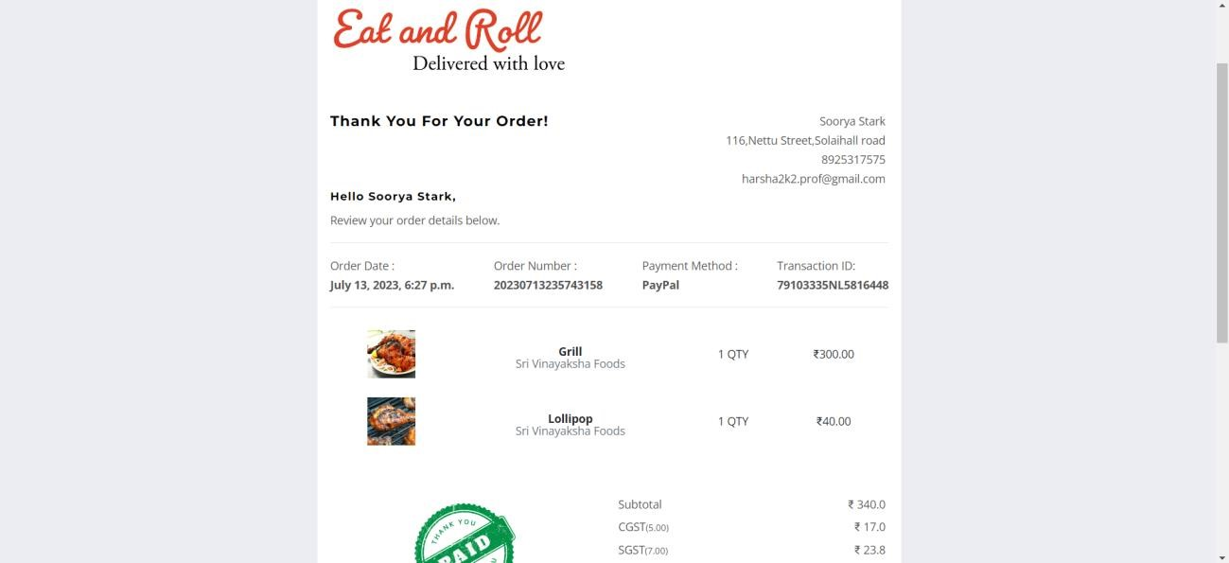

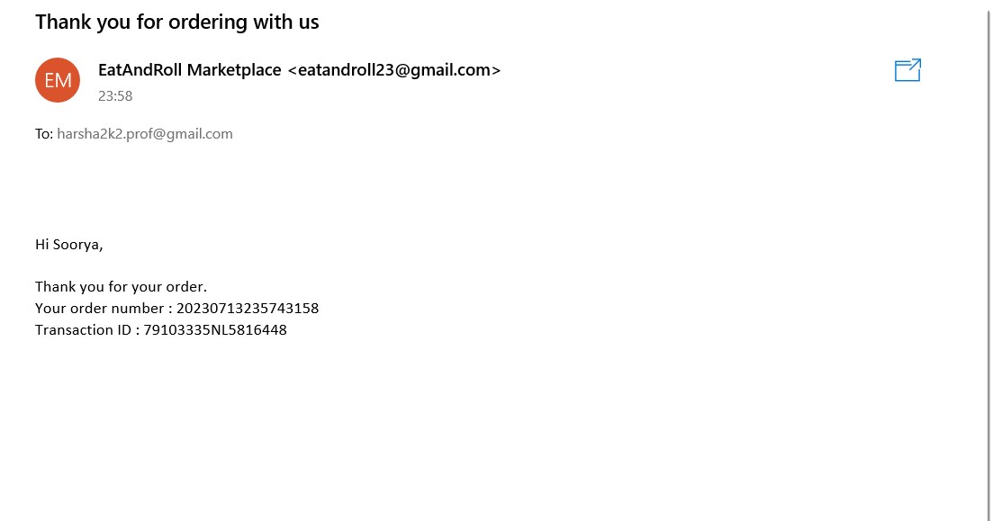

**3.6 CODE DESIGN :**

**USER AND VENDOR REGISTRATION :**

def registerUser(request): if request.user.is_authenticated: messages.warning(request, "You are already logged in") return redirect("custDashboard") elif request.method == "POST": print(request.POST) form = UserForm(request.POST) if form.is_valid():

first_name = form.cleaned_data["first_name"] last_name = form.cleaned_data["last_name"] username = form.cleaned_data["username"] email = form.cleaned_data["email"] password = form.cleaned_data["password"] user = User.objects.create_user( first_name=first_name, last_name=last_name, email=email, username=username, password=password,

)

user.role = User.CUSTOMER

user.save()

# send verification email

mail_subject = "Please activate your account" email_template = "accounts/emails/account_verification_email.html" send_verification_email(request, user, mail_subject, email_template)

messages.success(request, "Your account has been registered successfully !") return redirect("registerUser") else:

print("Invalid form") print(form.errors) else:

form = UserForm() context = { "form": form,

}

return render(request, "accounts/registerUser.html", context)

def registerVendor(request): if request.user.is_authenticated: messages.warning(request, "You are already logged in") return redirect("myAccount")

elif request.method == "POST":

# store the data form = UserForm(request.POST) v_form = VendorForm(request.POST, request.FILES) if form.is_valid() and v_form.is_valid():

first_name = form.cleaned_data["first_name"] last_name = form.cleaned_data["last_name"] username = form.cleaned_data["username"] email = form.cleaned_data["email"] password = form.cleaned_data["password"] user = User.objects.create_user( first_name=first_name, last_name=last_name, email=email, username=username, password=password,

)

user.role = User.VENDOR user.save() vendor = v_form.save(commit=False) vendor.user = user vendor_name = v_form.cleaned_data["vendor_name"]

vendor.vendor_slug = slugify(vendor_name) + "-" + str(user.id)

user_profile = userProfile.objects.get(user=user) vendor.user_profile = user_profile vendor.save()

# send verification email mail_subject = "Please activate your account" email_template = "accounts/emails/account_verification_email.html" send_verification_email(request, user, mail_subject, email_template)

messages.success( request,

"You account has been registered successfully ! Please wait for the approval.",

)

return redirect("registerVendor") else:

print("invalid form") print(form.errors) else:

form = UserForm() v_form = VendorForm()

context = { "form": form,

"v_form": v_form,

}

return render(request, "accounts/registerVendor.html", context)

**ORDER PLACEMENT :**

@login_required(login_url="login") def place_order(request):

cart_items = Cart.objects.filter(user=request.user).order_by("created_at") cart_count = cart_items.count() if cart_count <= 0:

return redirect("marketplace")

vendors_ids = [] for i in cart_items:

if i.fooditem.vendor.id not in vendors_ids: vendors_ids.append(i.fooditem.vendor.id) print(vendors_ids)

get_tax = Tax.objects.filter(is_active=True) subtotal = 0 total_data = {} k = {} for i in cart_items:

fooditem = FoodItem.objects.get(pk=i.fooditem.id, vendor_id__in=vendors_ids) v_id = fooditem.vendor.id

if v_id in k:

subtotal = k[v_id] subtotal += fooditem.price * i.quantity k[v_id] = subtotal else:

subtotal = fooditem.price * i.quantity k[v_id] = subtotal

# calculate tax_data tax_dict = {} for i in get_tax:

tax_type = i.tax_type tax_percentage = i.tax_percentage tax_amount = round((tax_percentage * subtotal) / 100, 2) tax_dict.update({tax_type: {str(tax_percentage): str(tax_amount)}}) # print(tax_dict)

# Construct the total data total_data.update({fooditem.vendor.id: {str(subtotal): str(tax_dict)}}) print(total_data)

subtotal = get_cart_amounts(request)["subtotal"] total_tax = get_cart_amounts(request)["tax"] grand_total = get_cart_amounts(request)["grand_total"] tax_data = get_cart_amounts(request)["tax_dict"]

if request.method == "POST":

form = OrderForm(request.POST) if form.is_valid(): order = Order() order.first_name = form.cleaned_data["first_name"] order.last_name = form.cleaned_data["last_name"] order.phone = form.cleaned_data["phone"] order.email = form.cleaned_data["email"] order.address = form.cleaned_data["address"] order.country = form.cleaned_data["country"] order.state = form.cleaned_data["state"] order.city = form.cleaned_data["city"] order.pin_code = form.cleaned_data["pin_code"] order.user = request.user order.total = grand_total order.tax_data = json.dumps(tax_data) order.total_data = json.dumps(total_data) order.total_tax = total_tax order.payment_method = request.POST["payment_method"] order.save() order.order_number = generate_order_number(order.id) order.vendors.add(*vendors_ids) order.save()

# Razorpay payment

DATA = {

"amount": float(order.total) * 100,

"currency": "INR",

"receipt": "receipt #" + order.order_number,

"notes": {"key1": "value3", "key2": "value2"},

}

rzp_order = client.order.create(data=DATA) rzp_order_id = rzp_order["id"]

context = { "order": order,

"cart_items": cart_items,

"rzp_order_id": rzp_order_id,

"RZP_KEY_ID": RZP_KEY_ID,

"rzp_amount": float(order.total) * 100,

}

return render(request, "order/place_order.html", context)

else:

print(form.errors)

return render(request, "order/place_order.html")

**PAYMENT PROCESSING :**

@login_required(login_url="login") def payments(request):

# check if the request is ajax

if (

request.headers.get("x-requested-with") == "XMLHttpRequest" and request.method == "POST"

):

# store the payment details in the payment model order_number = request.POST.get("order_number") transaction_id = request.POST.get("transaction_id") payment_method = request.POST.get("payment_method") status = request.POST.get("status")

print(order_number, transaction_id, payment_method, status) order = Order.objects.get(user=request.user,order_number=order_number) print(order) payment = Payment( user=request.user, transaction_id=transaction_id, payment_method=payment_method, amount=order.total, status=status,

)

payment.save()

# update the Oder model is_order to tru order.payment = payment order.is_ordered = True order.save()

# move the cart items to order food model cart_items = Cart.objects.filter(user=request.user) for item in cart_items:

ordered_food = OrderedFood() ordered_food.order = order ordered_food.payment = payment ordered_food.user = request.user ordered_food.fooditem = item.fooditem ordered_food.quantity = item.quantity ordered_food.price = item.fooditem.price

ordered_food.amount = item.fooditem.price * item.quantity # total amount ordered_food.save()

# send order confirmation email to customer

mail_subject = "Thank you for ordering with us" mail_template = "order/order_confirmation_email.html" context = { "user": request.user,

"order": order,

"to_email": order.email,

}

send_notification(mail_subject, mail_template, context)

# send order received email to vendor mail_subject = "You have received a new order" mail_template = "order/new_order_received.html" to_emails = [] for i in cart_items: if i.fooditem.vendor.user.email not in to_emails: to_emails.append(i.fooditem.vendor.user.email)

context = { "order": order,

"to_email": to_emails,

}

send_notification(mail_subject, mail_template, context)

# clear the cart if the payment is success cart_items.delete() response = {

"order_number": order_number,

"transaction_id": transaction_id,

}

return JsonResponse(response)

# Return back to ajax with the status success or failure

return HttpResponse("Payments view")

**AFTER ORDER CONFIRMATIONS:**

def order_complete(request):

order_number = request.GET.get("order_no") transaction_id = request.GET.get("trans_id") try:

order = Order.objects.get( order_number=order_number, payment__transaction_id=transaction_id, is_ordered=True,

)

ordered_food = OrderedFood.objects.filter(order=order) subtotal = 0 for item in ordered_food:

subtotal += item.price * item.quantity

tax_data = json.loads(order.tax_data) context = { "order": order,

"ordered_food": ordered_food,

"subtotal": subtotal,

"tax_data": tax_data,

}

return render(request, "order/order_complete.html", context)

except:

return redirect("home")

# IV SYSTEM TESTING

## 4.1 Unit Testing

Unit testing focuses verification efforts on the smallest unit of software design, the module. This is also known as "Module Testing" The modules are tested separately this testing is carried out during programming stage itself. In this step each module is found to be working satisfaction as regard to the expected output from the module.

## 4.2 Integration Testing

Integration testing focuses on the design and construction of the software architecture. Data can be lost across an interface; one module can have adverse effect on another sub functions and show on. Thus, integration testing is a systematic technique for constructing test to uncover errors associated with in the interface. In this project, all the modules are companied and then the entire program is tested as a whole.

## 4.3 User Acceptance Testing

User acceptance testing of a system is the key factor for the success of any system. The system under consideration is tested for user acceptance by constantly keep in touch with the prospective system user at time of developing and making changes wherever required.

## 4.4 Validation Testing

Validation testing is the requirement established as a part of software requirement analysis is validated against the software that has been constructed. This test provides the final assurance whether the software needs all functional, behavioural and performance requirements Thus, the proposed system under consideration has been tested by using validation testing and found to be working satisfactory.

# VI CONCLUSION

## FUTURE SCOPE

The future enhancement of the online food ordering project aims to elevate the user experience, expand the service offerings, and embrace emerging technologies. The following are the key areas of focus for future development:

* Advanced Personalization: Implement advanced personalization techniques using AI and machine learning algorithms to analyze user preferences, order history, and behavior. This will enable the platform to provide personalized recommendations, customized promotions, and tailored menus based on individual preferences, dietary restrictions, and previous orders.
* Voice and Natural Language Processing: Integrate voice recognition and natural language processing capabilities to enable customers to place orders, make inquiries, and interact with the system using voice commands. This enhancement will offer a hands-free and intuitive ordering experience through smart devices and voice assistants.
* Social Media Integration: Enable seamless integration with popular social media platforms to allow customers to share their food experiences, write reviews, and recommend restaurants to their friends. This feature will enhance user engagement, promote user-generated content, and attract new customers through social media referrals.
* Live Order Tracking: Implementing a live order tracking feature allows customers to track the progress of their delivery in real-time. This can be achieved by integrating GPS technology with the delivery personnel's mobile devices. Customers can access a map view that shows the current location of the delivery person and their estimated time of arrival.

## BIBLIOGRAPHY

* Garg, R., & Bajaj, S. (2020). A Comprehensive Study of Online Food Ordering Systems. International Journal of Innovative Technology and Exploring Engineering (IJITEE), 9(1), 2385-2389.
* Chai, J., Qu, H., & Zhong, L. (2019). Understanding Online Food Delivery Apps: An Integrated Model of Technology Acceptance and Service Quality. International Journal of Hospitality Management, 77, 401-413.
* Singh, A., & Aggarwal, P. (2017). Online Food Ordering: A Review and Future Directions. Journal of Indian Business Research, 9(1), 30-59.